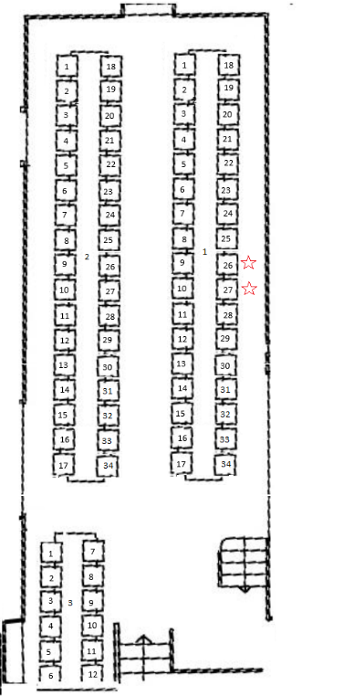

Table 1
1-
2-
3-
4-
5-
6-
7-
8-
9-
10-
11-
12-
13-
14-
15-
16-
17-
18-
19-
20-
21-
22-
23-
24-
25-
26-
27-
28-
29-
30-
31-
32-
33-
34-

Table 2
1-
2-
3-
4-
5-
6-
7-
8-
9-
10-
11-
12-
13-
14-
15-
16-
17-
18-
19 –
20-
21-
22-
23-
24-
25-
26-
27-
28-
29-
30-
31-
32-
33-
34-
Table 3
1-
2-
3-
4-
5-
6-
7-
8-
9-
10-
11-
12-

