Seating in the courtyard

Courtyard Barn
`
Patio table
4
Dodford
Room

Dodford
Room
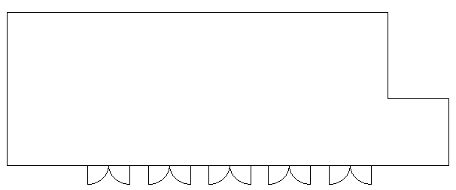
Sofa area
10
Pre-ceremony/post-ceremony seating in the courtyard
The sofa areas can seat a maximum of 10 guests in 4 households, although two single guests could be distanced and treated as one household.
The patio tables will seat a maximum of 4 guests in 2 households.
Other seating can be organized it depends on your household groups.
On sunny summer days we can move the garden furniture to the lawn area and create a seating plan there too!

Sofa area
10
4
Patio table
Photographer
Registrar

Registrar
Honeymoon
Suite

