Courtyard Barn lay-out for 30 person ceremony

`

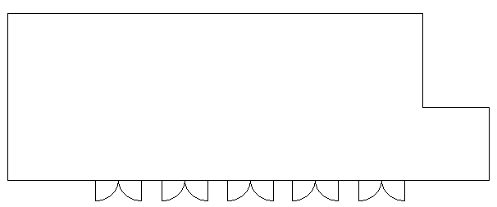

Middle Ceremony
This layout gives more flexibility for fitting different sized groups. The chairs can be fanned around the marriage table and distanced 1m+ depending on the groups.
The room will feel more ‘full’ with this layout.
Registrar
Registrar
Traditional Aisle
Only members from the same household can sit next to each other in twos, so ‘single’ households will need to sit on their own.
We have space for more rows if there are more people in single households attending

Photographer
Registrar
Registrar

