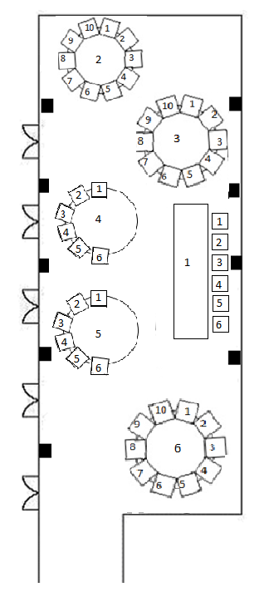

Table 1 (Top Table)
1-
2-
3-
4-
5-
6-

Table 2
1-
2-
3-
4-
5-
6-
7-
8-
9-
10-

Table 3
1-
2-
3-
4-
5-
6-
7-
8-
9-
10-
Table 4
1-
2-
3-
4-
5-
6-

Table 5
1-
2-
3-
4-
5-
6-

Table 6
1-
2-
3-
4-
5-
6-
7-
8-
9-
10-

