Layout for Round Tables in the Courtyard Barn

Courtyard Barn with round tables
`

Dodford
Room

4
Dodford
Room
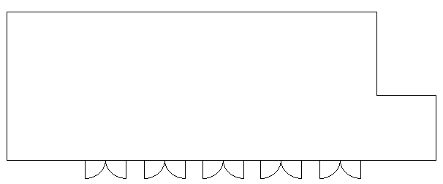
We can seat a maximum of 30 people with current regulations on round tables in the Courtyard Barn. During the summer months you may consider placing some of the tables on the top level of the patio.
The larger tables are 5’6” and we can seat 6 people in pairs at these tables with 1m+ distancing in place. The smaller table at the top of the barn is only 5’ in diameter so it would be best to have a maximum of 4 guests in couples here, although it could accommodate a larger household.
There must be at least one pair on each table of 6, if you have a number of ‘single’ households the maximum on the table will be 5.
Evening reception:
Guests can return to the barn after speeches outside or in the Catesby Barn in the early evening. We can create a different seating plan and would sanitize all furniture before it is reused. We would recommend you use luggage tags for the chairs so guests can return to the same chair in the evening.
It will not be possible to fit a live artist with a 2m space if your numbers are at the maximum. If you are planning live entertainment in the evening you will need to be outside or use the Catesby Barn. Please discuss your option with us.

4/6
4/6
4/6
4/6
4/6
4/6
4/6
4/6

Honeymoon
Suite

