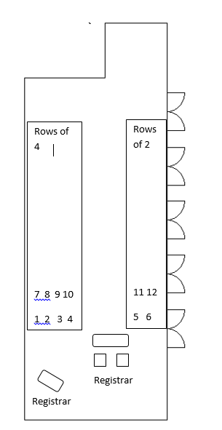

**Ceremony seating plan**

We would recommend that you reserve the first few rows of seating allowing space for your parents and those taking part in the aisle walk. The Best man and anyone doing a reading will need to get out easily. You will stand for most of the ceremony and sit at the table to sign the register.

Please let us know your seating plan for the ceremony

1. 8.

2. 9.

3. 10.

4. 11.

5. 12.

6.

7.

**`**