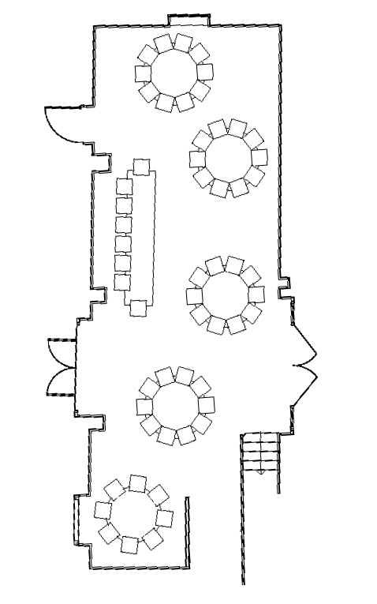
8
7
6
5
4
3
2
1
8
7
6
5
4
3
2
1
10
9
8
7
6
5
4
3
2
1
10
9
8
7
6
5
4
3
2
1
6
5
4
3
2
1
10
9
8
7
6
5
4
3
2
1
10
9
7
8
6
5
4
3
2
1
Top Table (Table 1)  1-  2-  3-  4-  5-  6-  7-  8- | Table 4  1-  2-  3-  4-  5-  6-  7-  8-  9-  10-
Table 2  1-  2-  3-  4-  5-  6-  7-  8-  9-  10- | Table 5  1-  2-  3-  4-  5-  6-  7-  8-  9-  10-
Table 3  1-  2-  3-  4-  5-  6-  7-  8-  9-  10- | Table 6  1-  2-  3-  4-  5-  6-  7-  8-

